My trauma reminded me what I really want!

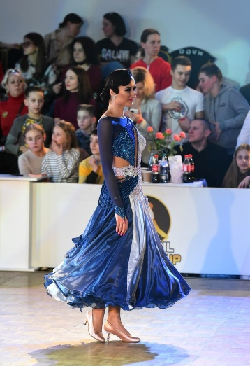We were preparing for Blackpool, which was postponed over and over again. We took lessons and danced the finals, we exhausted ourselves at physical training and believed this is the starting point, that will show whether we made a breakthrough in these 2 years... We wanted, and believed, and made every effort, but...

A week before departure, I landed badly in quickstep and broke my leg.

On the very first day, for the first time in 30 years, a plaster cast is applied to me. Should I write about tears of disappointment and resentment - not pain, but a sorrow for failed plans? In this situation competitions in Blackpool were impossible, but there was still hope for the International and the European show dance championship. I believed that after 5 days, the fracture would still not be found, and when the edema subsides, everything would be fine. After 5 days of a new life in a cast, moving on crutches or all fours, (when it was necessary to bring something), after washing your head on one leg upside down, lying position 24/7, learning to go down and upstairs in a new way, I was told that there is no fracture! But the happiness lasted only 3-5 minutes... After that, removing my plaster cast, the doctor said: "Well, now on crutches, try to transfer no more than 10% of your weight to your leg." 10% it's only 5.3 kilos! The weight which is even embarrassing to lift in the gym! And when I tried to do it, I could not! Terrible pain pierced my leg. The question "will I be able to dance our "Imagination" show with jumps and lifts in 10 days, and in 20 days the International rounds" - was not relevant. There is a long recovery process ahead. Everyone says: "This is a sign, the Universe wants it, you will receive something more instead!" But I understand that the way to my dream was closed for a long time. When on that first day the doctor, applying a plaster cast, and saw me crying, he thought that I was painful and scared... But it was an offense, anger to the situation, fate, and the most warmed up for no reason betrayed me ankle. And first of all, it was a huge grief for the broken dreams I sincerely wanted to catch.

Now, my next goal is the UK championship. And what can I say about the situation, happened to me: **"lack of possibility to walk reminded me how much I want to dance!"**

**And I will, no matter what!**

To all my colleagues and friends, I want to say something: "Even in your daily routine, even if you are tired appreciate every moment being on a dance floor, enjoy every movement, be in a harmony with your partner and thanks God for this magic opportunity to breathe, walk and dance! Never forget and never lose this feeling!"

With love, Tania.